Pip install

apt install python-pip

LAMP

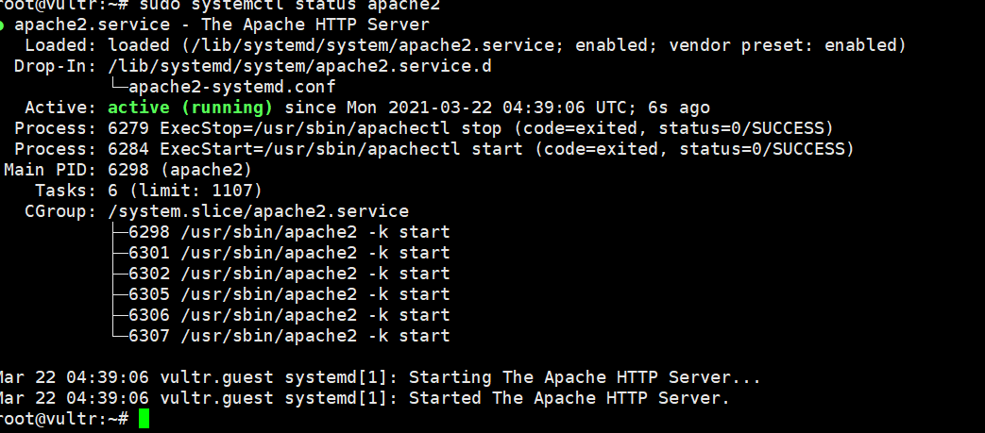

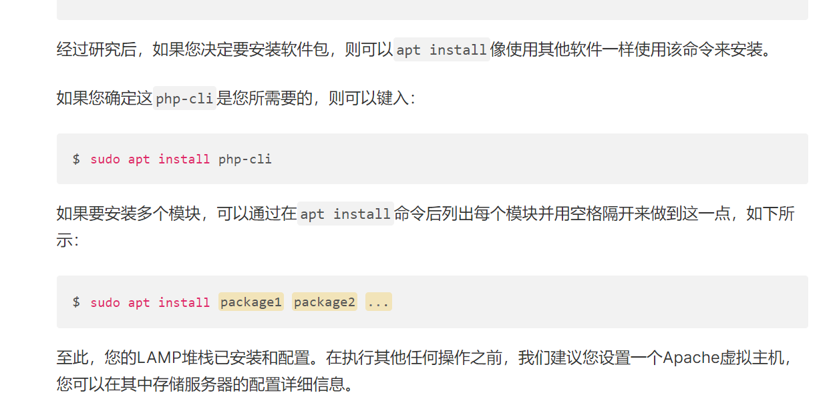

<https://www.digitalocean.com/community/tutorials/how-to-install-linux-apache-mysql-php-lamp-stack-ubuntu-18-04>

<https://www.digitalocean.com/community/tutorials/how-to-secure-apache-with-let-s-encrypt-on-ubuntu-18-04>

Header decode jwt-decode.header 'JWT TOKEN HERE'

Payload decode jwt-decode.payload 'JWT TOKEN HERE'

Details for jwt-decode

sudo apt-get install coreutils